This program must run in python 3.7 or above!!!

Library used: pyocclient

Link: <https://github.com/owncloud/pyocclient>

After setup python 3.7.x environment,

Run "pip install pyocclient" in CMD to install pyocclient

IDE: JetBrains PyCharm 2018.3 x64

Link: <https://www.jetbrains.com/pycharm/>

Community edition is good to go

If there is any missing library, PyCharm will remind you to install

Run run.py, or shortcut key (Shift + F10)

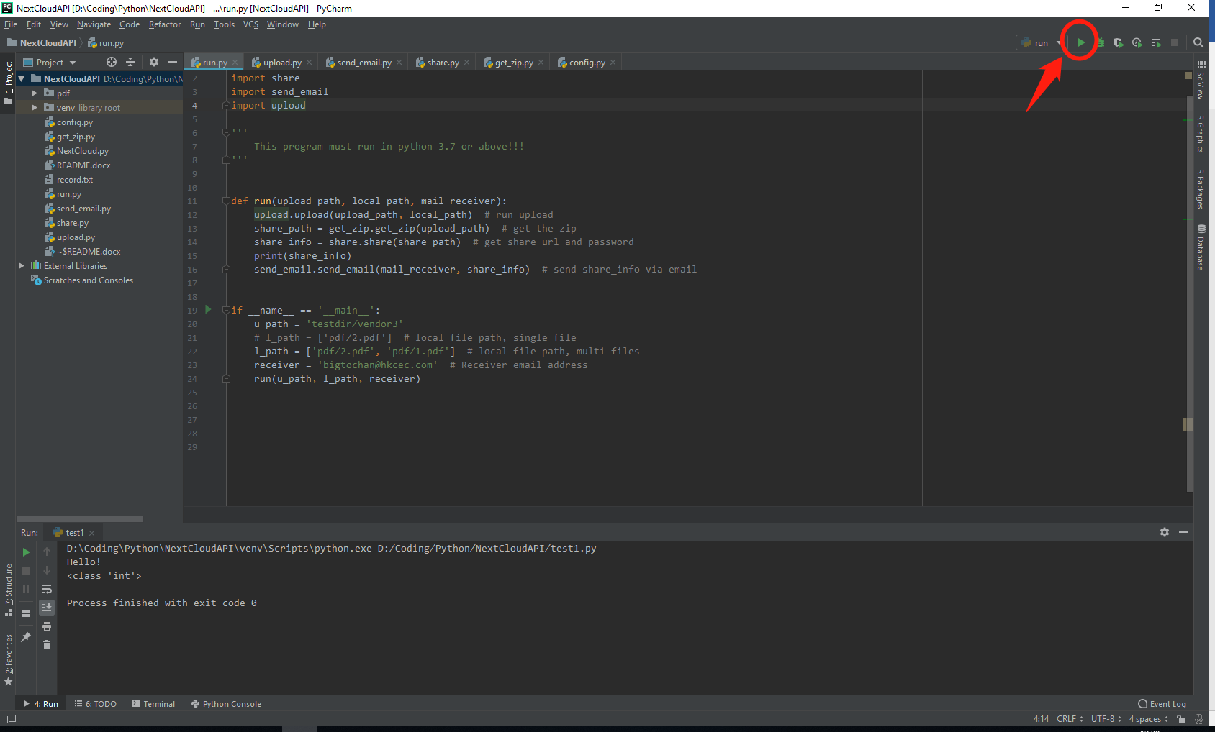

Alternatively, run modules separately, just change parameters under

if __name__ == '__main__':

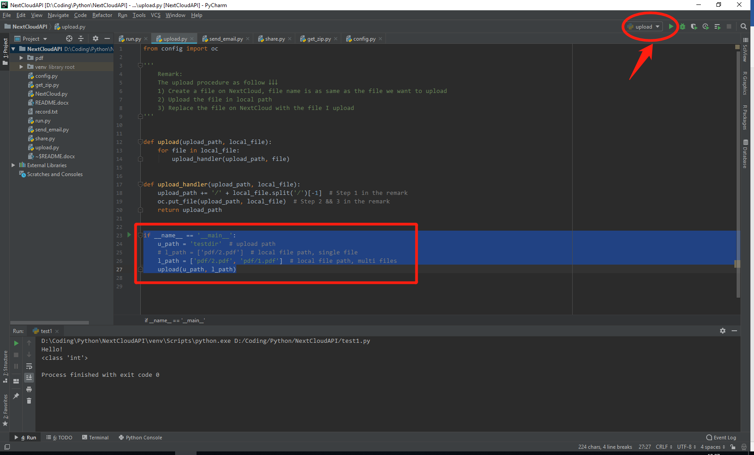

Press Ctrl and point to the function, can view the source code of that function.

